- Ethical and Legal Issues
A man without ethics is a wild beast loosed upon this world.—Albert Camus
In your professional career you are going to face ethical dilemmas, and how you respond to them will affect your reputation, your employability, and the welfare of others. Systems are developed for use by other people, and the decisions that go into their design impacts the health and safety of those people. There are plenty of high profile examples, such as the two space shuttle disasters, that make it clear that the decisions of engineers and scientists have serious implications. Beyond issues in the technical aspects of design, there are professional ethics that govern the broad scope of interactions between people in the workplace. The aim of this chapter is to present the basics of engineering ethics and provide guidance for addressing dilemmas when they arise. It presents a basic overview of morality and ethics, professional codes that apply to the engineering profession, intellectual property and legal issues as they relate to design, how to apply ethics throughout the design process, and guidance for handling ethical dilemmas. The chapter concludes with case studies that provide an opportunity to apply ethical decision-making skills.
Learning Objectives
By the end of this chapter, the reader should:
- Understand what is meant by morals, ethics, and values.
- Be familiar with the IEEE Code of Ethics.
- Understand what a patent is, the criteria for filing for one, and the elements that constitute it.
- Understand the difference between patents, trade secrets, and copyrights.
- Understand the concepts of negligence and strict liability as they apply to product design.
- Understand how to incorporate ethical issues throughout the design process.
- Be able to analyze ethical case studies and suggest solutions to the dilemmas that they embody.
  - Ethical Theory in a Nutshell
Here is an ethical dilemma to consider as we start our discussion. Let’s assume that you are conducting a job search during your senior year in college and have interviewed with several prospective employers. Company A offers a you job and you accept the position and you sign a contract agreeing upon a starting salary, position, and start date. Two weeks later, Company B also offers you a job with a higher starting salary and work that you find personally more interesting. You have a choice to make. Do you turn down the offer of Company B and stay with A? Or do you accept the offer made by B and then inform A that you are not going to work for them? This is a classic dilemma that many students will face, and rather than trying to answer it now, let’s revisit it later.
There is often confusion as to what exactly is meant by the related concepts of ethics and morals. Morality is concerned with principles of right and wrong and the decisions that derive from these principles. Morals are often taught by stories that are common in all cultures, such as Aesop’s fable of the boy who cried wolf. In this story, the boy was watching sheep and cried wolf when there was no wolf present. In response, all of the villagers came running to help him, only to find no wolf. When the wolf did later appear and the boy cried for help once again, nobody believed him nor came to help, and the wolf scattered the flock. The moral of this story is that it is wrong to lie, and when a person becomes known as a liar, nobody will believe him/her even if he/she is telling the truth.
The term ethics is closely related to morals and they are often used interchangeably. According to the American Heritage Dictionary, ethics is defined as:
1. Branch of philosophy that deals with the general nature of good and bad and the specific moral obligations of and choices to be made by the individual in her/his relationship to others. 2. Rules or standards governing conduct, especially those of a profession.
Ethics is the philosophy or study of moral obligations and the choices to be made by individuals. It is important to understand that if there is no decision to be made, there is no ethical dilemma. The choices to be made are based upon a belief as to what is good or bad, and the decisions must impact relationships to others.
Morals derive from principles, which are fundamental laws or rules that govern behavior. An example of a principle is the Golden Rule, which states that people should treat others as they themselves would like to be treated. The Golden Rule is a universal principle and embodied in one form or another in all major religions and belief systems of the world. Another example of a principle is the belief that people should be honest and trustworthy in their dealings with others. Value is another term that is often heard in ethical discussions. A value is something that a person or group believes to be valuable or worthwhile. This could be relatively innocuous such as valuing baseball as a sport, or something more significant such as valuing hard work. A group of thieves may believe that it is valuable to steal from other people, but not from their own group. As these examples show, shared values may be good or bad. The final example clearly violates the principles of the Golden Rule and is considered bad by most people.
Rule-based ethics are based upon a set of rules that can be applied to make decisions. In the strictest form they are considered to be absolute in terms of governing behavior—either you follow the rule (good) or break the rule (bad). This type of an ethical system is based upon the principles of universality and transitivity. Universality means that the governing rules are such that they can be accepted by everyone, while transitivity means that you would accept others applying the same decision to you. A problem with rule-based ethics is defining a universal set of rules that everyone can agree upon. There may be a few rules or principles that can be agreed upon by all, but going beyond that is difficult.
Conditional rule-based ethics means that there are certain conditions under which an individual can break a rule. This is generally because it is believed that the moral good of the situation outweighs the rule. For example, if you have a seriously injured person in your car and are transporting them to the hospital, is it acceptable to exceed the speed limit? In this case, it may be deemed that the moral good of getting the person prompt medical attention outweighs the obligation to obey the speed limit. It is generally believed that killing others is wrong, except in the case of war. Is it acceptable to cheat on an exam because you stayed up all night to help your sick roommate? Or is it acceptable to cheat because you simply did not have enough time to study because of your other obligations? In each of these cases a moral choice has to be weighed.
In utilitarian ethics, decisions are made based upon the decision that brings about the highest good for all, relative to all other decisions. This sounds appealing, but has drawbacks in that bad choices may need to be made for certain parties in order to achieve this overall good. It becomes very difficult to determine exactly what the highest good is. Situational ethics are where decisions are made based on whether they produce the highest good for the person. In this case, decisions are made based upon the impact to the individual and situation at hand. This is generally considered a poor ethical decision-making approach.
Let’s conclude this section with a new scenario. Let’s assume that you are conducting a job search and Company A offers you a job, you agree upon terms of the offer, accept it, and sign a contract. You then inform the other companies that interviewed you that you are no longer available. One month later Company A calls you and notifies you that they are rescinding their offer. Although they can no longer offer you the job, they will provide you with $1,000 in compensation for rescinding the offer. You later find out that Company A just offered the exact same job to another student in your class who has a higher grade point average than yours and more experience with the technical products they design. Was the decision of the company ethical? Returning to the original case, is it ethical for the student to rescind their acceptance of the original job offer and then accept the other?
  - The IEEE Code of Ethics
Most engineering disciplines have associated with them a professional society or organization. In electrical and computer engineering two important ones are the Institute of Electrical and Electronics Engineers (IEEE) and the Association for Computing Machinery (ACM). The objective of professional societies is to promote and support their respective fields. They offer a variety of services and benefits to their members, such as access to technical information, networking opportunities, and financial services. They also define accepted practices of their members that are embodied in an ethical code. In fact, professional societies were originally created to provide guidance for ethical practices in their field and to ensure the safety of the public. The IEEE Code of Ethics, shown in Table 11.1, applies broadly to the electrical, computing, and software fields.
Table 11.1 The IEEE Code of Ethics.
We, the members of the IEEE, in recognition of the importance of our technologies in affecting the quality of life throughout the world, and in accepting a personal obligation to our profession, its members and the communities we serve, do hereby commit ourselves to the highest ethical and professional conduct and agree:
1. to accept responsibility in making engineering decisions consistent with the safety, health and welfare of the public, and to disclose promptly factors that might endanger the public or the environment;
2. to avoid real or perceived conflicts of interest whenever possible, and to disclose them to affected parties when they do exist;
3. to be honest and realistic in stating claims or estimates based on available data;
4. to reject bribery in all its forms;
5. to improve the understanding of technology, its appropriate application, and potential consequences;
6. to maintain and improve our technical competence and to undertake technological tasks for others only if qualified by training or experience, or after full disclosure of pertinent limitations;
7. to seek, accept, and offer honest criticism of technical work, to acknowledge and correct errors, and to credit properly the contributions of others;
8. to treat fairly all persons regardless of such factors as race, religion, gender, disability, age, or national origin;
9. to avoid injuring others, their property, reputation, or employment by false or malicious action;
10. to assist colleagues and co-workers in their professional development and to support them in following this code of ethics.
Approved by the IEEE Board of Directors, August 1990

Some of the values embodied in the code are that of treating others with fairness and respect (8–10), honesty and trustworthiness (2–4), and professional competence (6–7). The importance of the safety of the public is clearly identified in the first and ninth items of the code. The code provides a common basis for analyzing ethical cases studies and is applied for these purposes in subsequent sections.
  - Intellectual Property and Legal Issues
It is important to understand some legal issues, particularly as they impact product design and development. The first considered is intellectual property, which seeks to answer the question of who owns an idea or invention. The second is that of legal liability, which comes into play if somebody is injured or harmed by a product or system.

Intellectual Property
The intent of designing a new product is usually to sell it for a profit, which leads to the issue of ownership of both the intellectual property and the profits. The tools for protecting intellectual property are patents, trade secrets, and copyrights. Be aware that when you enter the workforce as an engineer, your employer may ask you to sign an agreement assigning their company rights to all of the intellectual property that you create while in their employ. Such contracts are common and enforceable.
The most well-known way of protecting a design or invention is with a patent. If a patent is held for a technology, others cannot use it without permission of the owner. The owner can deny others the right to use it, or grant the right to use it in exchange for monetary compensation. The two types of patents are utility and design patents. The United States Patent and Trademark Office (USPTO) defines the difference between the two as follows:
A utility patent may be granted to anyone who invents or discovers any new and useful process, machine, article of manufacture, compositions of matter, or any new useful improvement thereof. A design patent may be granted to anyone who invents a new, original, and ornamental design for an article of manufacture.
The one that is of most interest for this discussion is the utility patent, as the design patent focuses on aesthetic design issues.
In order to be granted a utility patent, the invention must meet three conditions: it must be novel, non-obvious, and useful. Novelty means that the idea must be new and that nothing like it already exists. It cannot be an idea that is already patented or has been published for more than a year. The non-obvious condition means that another person would not be expected to develop the same idea based upon existing technology. As an example, for personal computers, it would not be possible to patent the idea of increasing data storage by adding multiple disk drives, since this is an obvious extension of existing technology. Useful means that the device must perform a useful function and be able to be reduced to practice. You could not patent the concept for a transporter of the type seen on science fiction shows, such as Star Trek, where people are beamed instantaneously through space from one place to another—unless of course you can reduce it to practice.
To a file a patent, extensive research needs to be done to be sure that the idea is novel. A good place to start is the US Patent Trademark Office (USPTO) website (www.uspto.gov) and its searchable database of patents back to 1790. The database allows full text search of patents from 1976 forward and patent number search back to 1790. It provides full images of all patents in the database. The website also has information on how to apply for a patent and describes the differences between patents, trademarks, and copyrights. The elements that are contained in a patent are:
- A citation of prior art. This is similar patents and publicly reported technology.
- A description of the invention. This describes how it operates and how it would be reduced to practice.
- Claims. They are the legal description of the invention and its unique aspects.
The claims are used to determine if another party is infringing upon a patent, and thus they must be carefully thought out and properly worded. If the claims are too broad or too specific then they may not provide much protection. There are fees for filing the patent and for periodic maintenance that can cost between $5,000 and $10,000 over the life of the patent. Hiring a good patent attorney is invaluable in the application process and will cost money—it is not unusual to spend $20,000 for lawyer and application fees. When selecting a patent attorney, make sure that he/she has a good track record and reputation.
An example patent for a hardware design of a fast floating point overflow and sign detection unit (US Patent #6,779,013) is shown in Figure 11.1. The patent is owned by Intel Corporation and the inventor was one of their employees. The first page identifies prior art that relates to this patent. This includes previous patents related to this technology, which in this case goes back to 1991. It is not unusual to cite prior patents that go back 50 or 100 years. In addition to patents, prior art in publicly available literature is identified. The first page also identifies the number of claims and supporting figures, and shows the high-level design architecture. A description of the system starts on the second page as shown in Figure 11.1 (b). The complete description is fairly lengthy and only the first page is shown. It is similar to a technical report in that it provides background on the technology and describes the invention and its operation in detail. The final page of the patent (Figure 11.1 (c)) identifies the legal claims that make the invention unique.
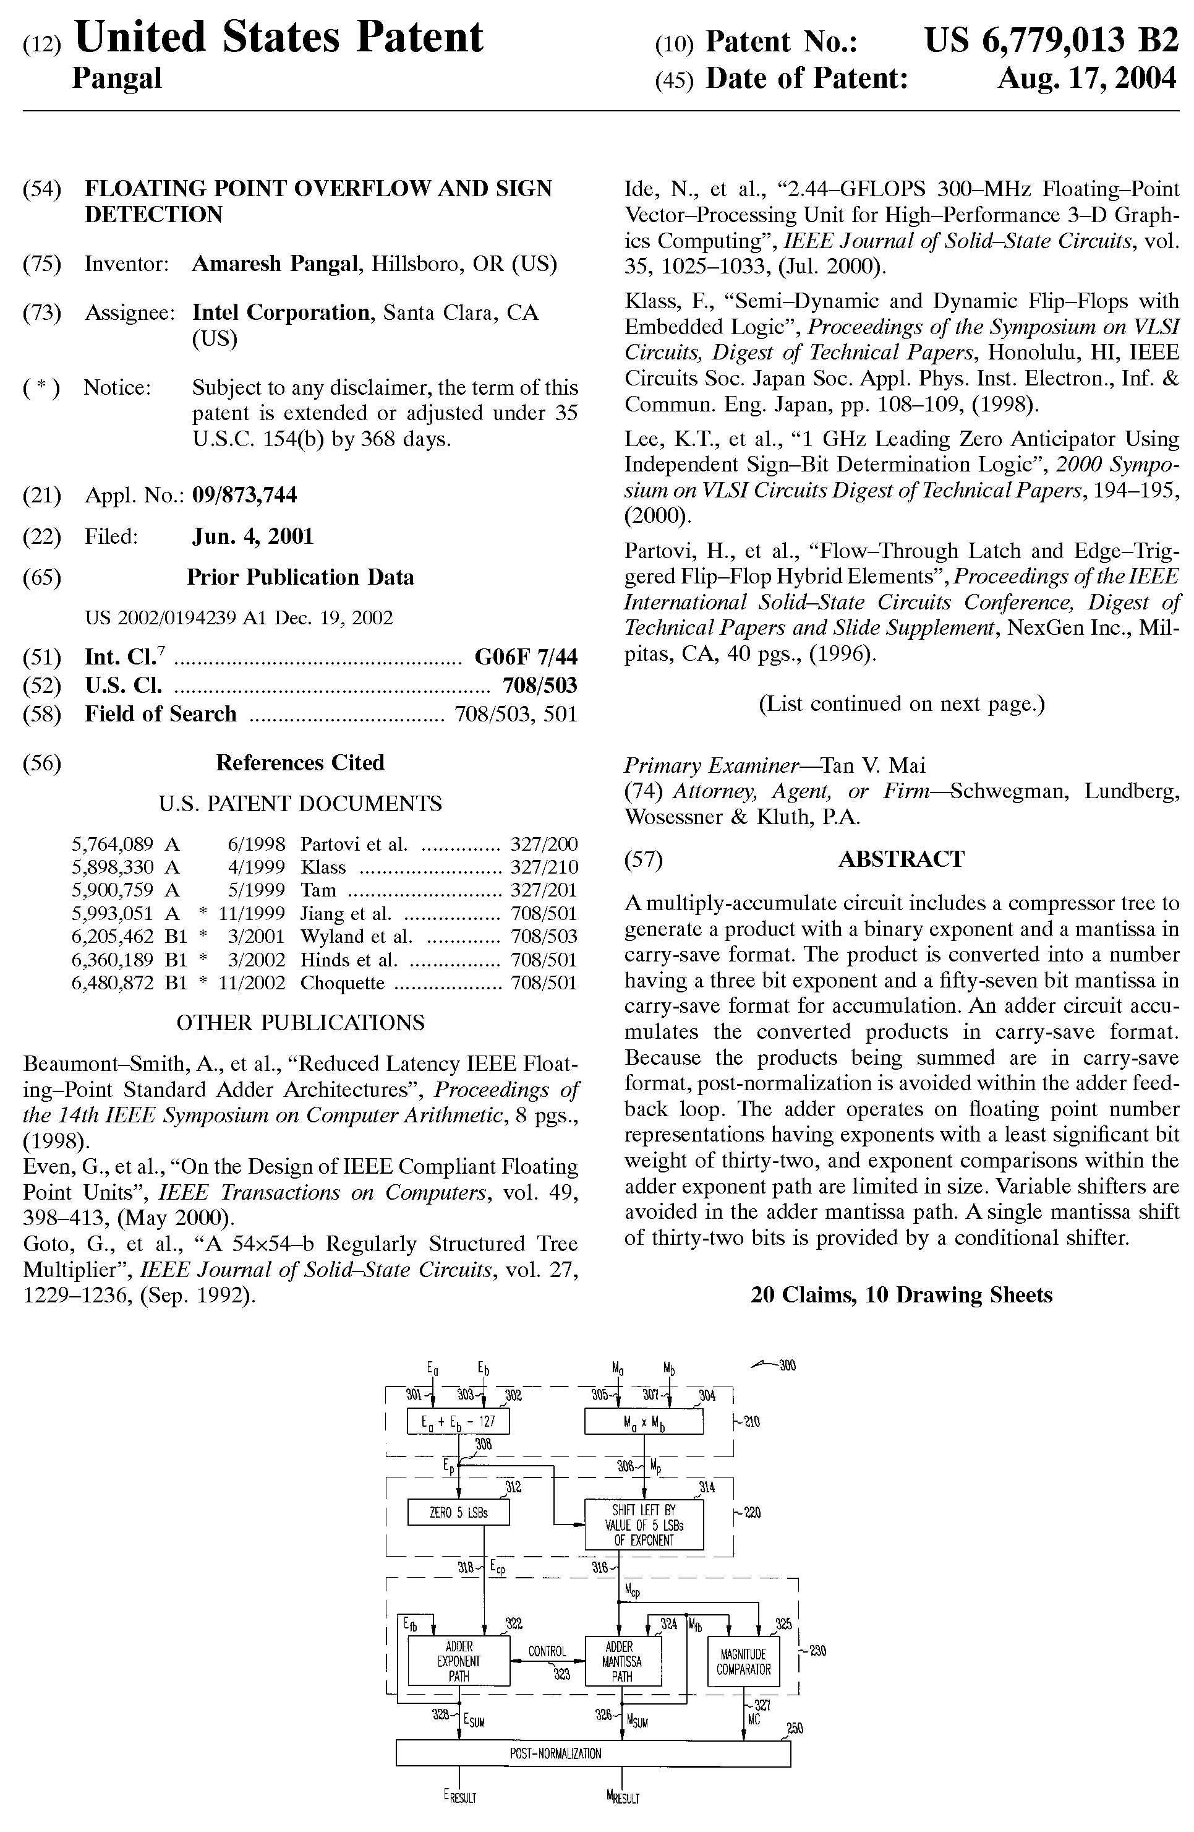
Figure 11.1 (a) Example of a US patent for a floating point overflow and sign detection unit.
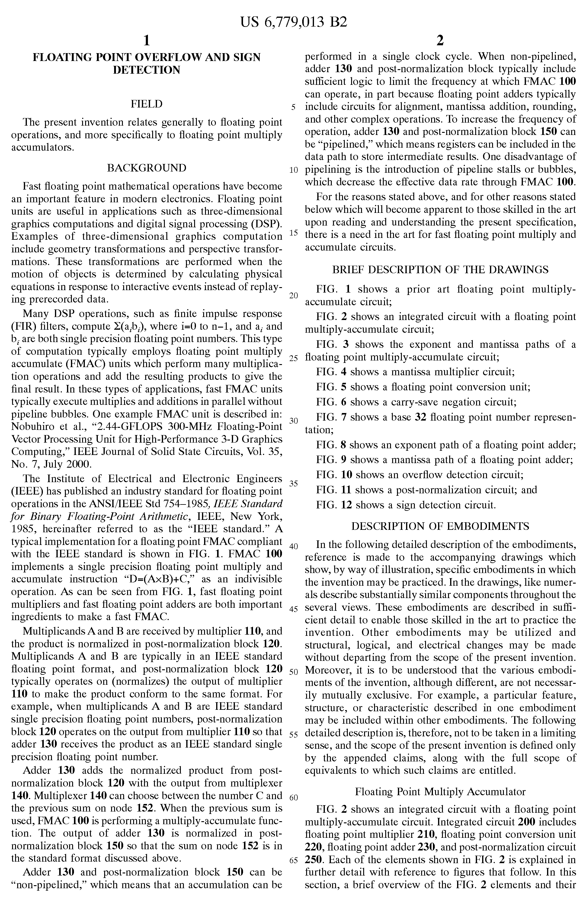
Figure 11.1 (b) First page of the patent description.
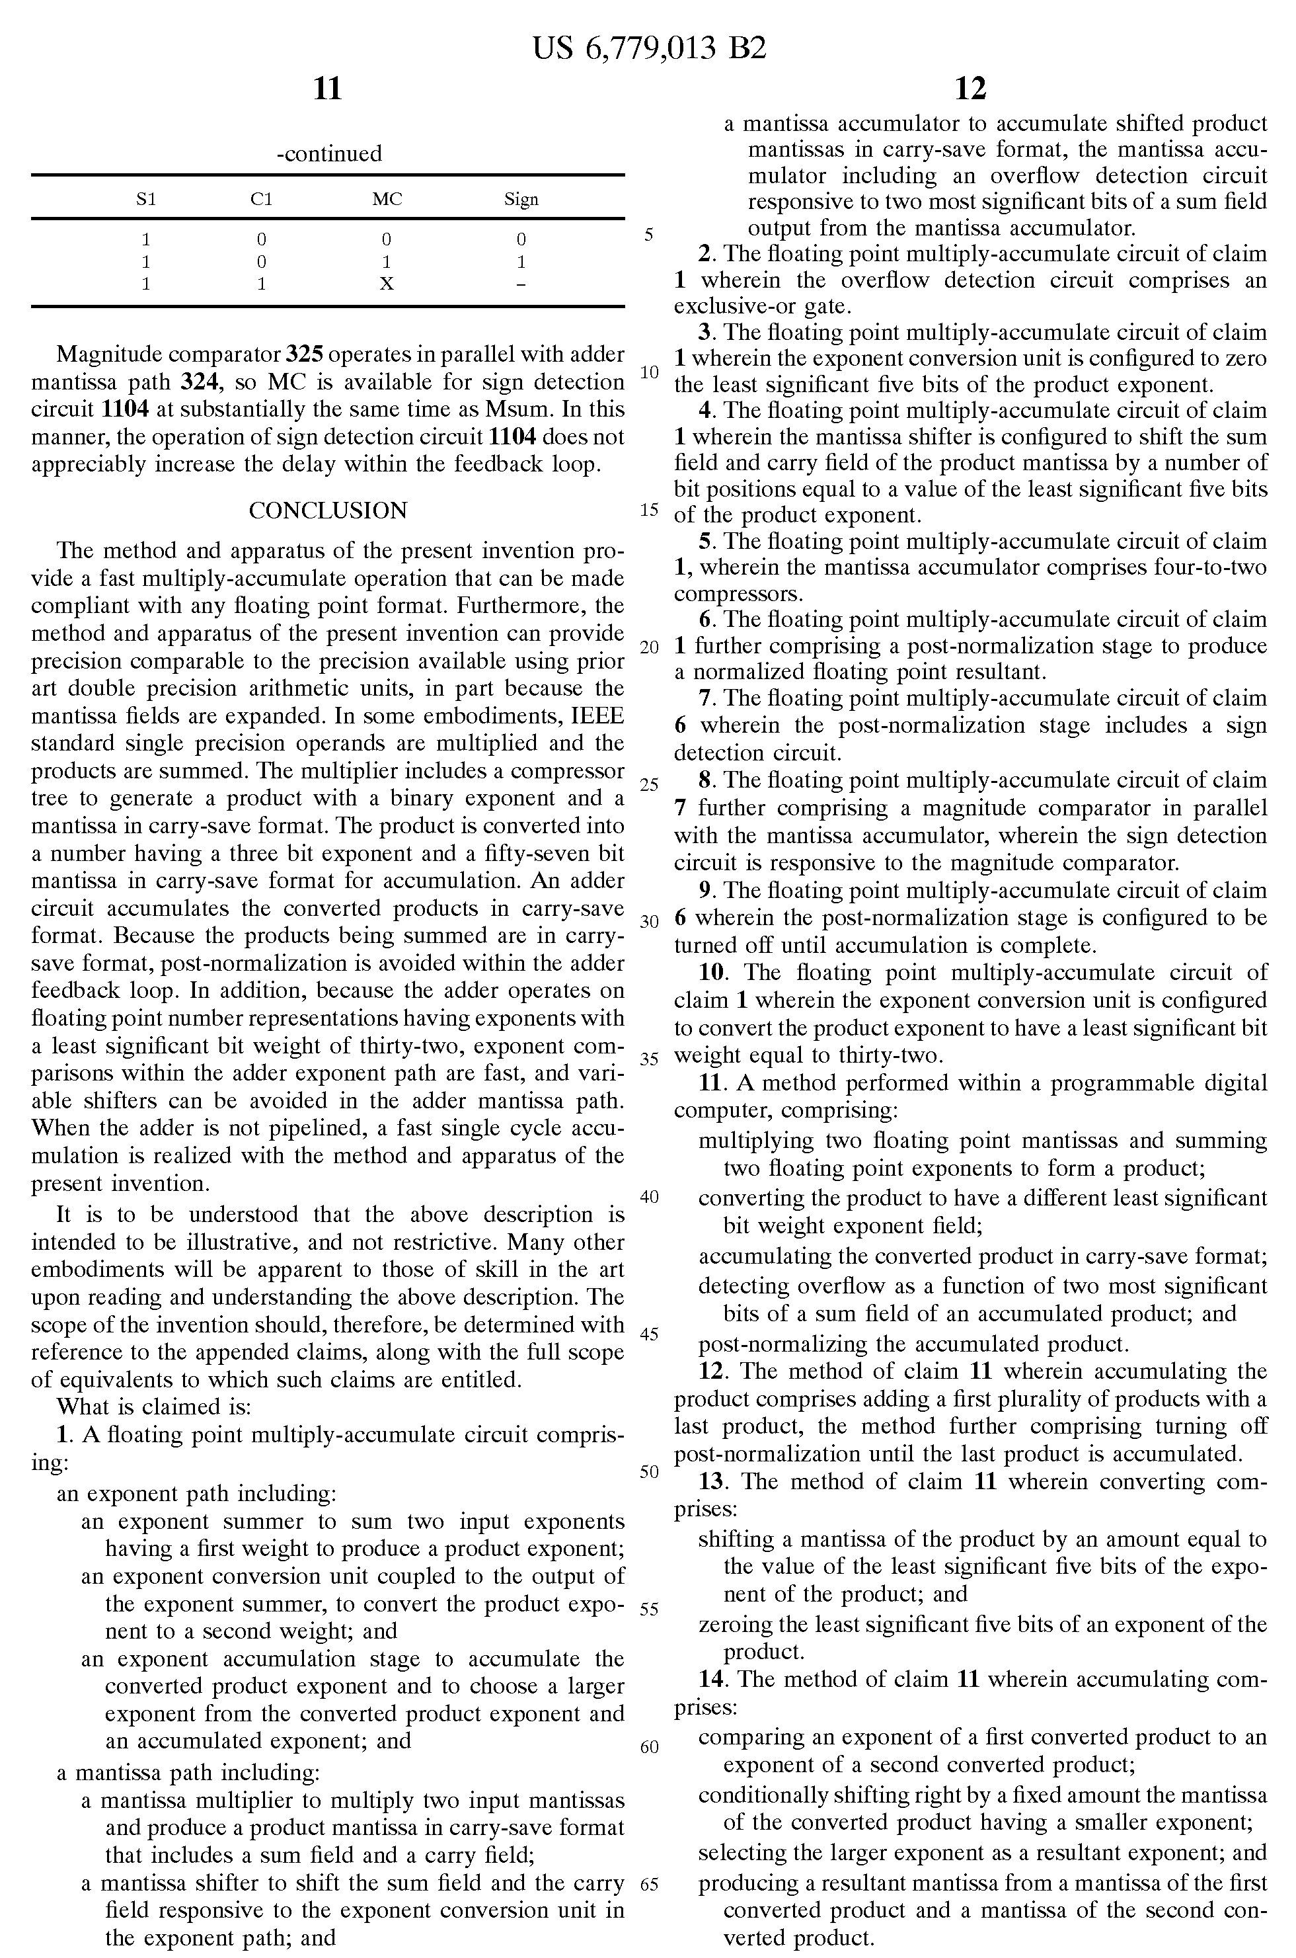
Figure 11.1 (c) Conclusion of the patent and its claims.
In the United States, patents are granted based upon the concept of first to conceive the invention, not first to file the patent application. If two parties are applying for a patent at the same time, then the one who demonstrates that they were the first to conceive the idea and reduce it to practice receives the patent. Good records must be maintained to prove this. It is done by recording inventions in a bound design notebook with numbered pages that cannot be removed. All entries should be clearly described, understandable by other engineers, and be signed and dated. For the best protection, entries should be signed and witnessed by at least one other person and the notebook should be occasionally notarized. Pages should not be removed from the notebook and entries should be made in non-erasable pen. Mistakes and blank spaces should be crossed out, signed, and dated. Figures should be drawn directly in the notebook, while computer generated figures are pasted in so that they are not removable. It is good practice to maintain a design notebook even if you are not planning to patent your ideas.
Once a patent is granted, it is good for 20 years—after it expires, the invention is fair game for anybody to use. Let’s assume that you are the owner of a patent and you find that somebody is infringing upon it. Is the government going to come in and start legal action against the infringer? No—a patent only gives the owner a right to sue others if they infringe upon it. The government does not actively seek out offenders and protect your intellectual property. The owner of the patent must protect it.
There are drawbacks to patents. The owner must be vigilant in defending a patent and may have to initiate legal action to do so. Once an idea is patented, it is made public for all to see on the government’s website. This may not be a good idea depending upon the technology and competitive situation. An alternative that many companies employ to protect intellectual property is to hold them as trade secrets. Obviously, the idea must be kept secret so that others cannot find out about it. This is often done by restricting the number of people who have access to the idea and by having those who do know about it sign a non-disclosure agreement. It is common practice for companies to ask employees and visitors to their facilities to sign a non-disclosure agreement that prevents the signer from disseminating information about their products, services, and trade secrets. If one breaks a non-disclosure agreement, they can be held legally liable. Trade secrets pose another type of risk to a company, since once the secret is revealed, it is fair game for competitors. One way to determine a competitor’s trade secrets is through the use of reverse-engineering, where a device or process is taken apart to understand how it works. Reverse-engineering is legal if the information is obtained through legal means, but one must be careful with the information that is obtained and not copy it unless legally allowed to do so. The Digital Millennium Copyright Act of 2000 prohibits breaking technological protections, such as encryption, to learn about a competitor’s product.
Copyrights protect published works such as books, articles, music, and software. A copyright means that others cannot distribute copyrighted material without permission of the owner. It is easy to obtain a copyright—all that a person has to do to copyright material is indicate the word “copyright” on the work, along with the year of publication, and identify the name of the copyright holder. Copyrights can be officially registered through the US Copyright Office, and it is a good idea to do so for involved works such as writing a book or publishing music. Registering provides a stronger legal basis for pursuing claims. Copyrights are good for the lifetime of the holder plus 50 years, while for a company they are good for 75 years.

Liability and Negligence
Civil lawsuits, which are those that are relevant for our discussion, are those in which one party sues another. They involve something that is known as a tort, which serves as grounds for the lawsuit. A tort is a wrongful act, though not necessary illegal, for which a civil lawsuit can be brought, including product liability. A company or person can be sued for damages caused by a product design and be held liable for them, meaning required to pay monetary damages.
The two standards for determining legal liability in tort law are that of negligence and strict liability. In the case of negligence, it must be shown that the manufacturer did not follow reasonable standards and rules that apply to the situation and also committed a wrongful act. Exactly what constitutes reasonable has to be determined for the particular case. For a product design, a manufacturer can be held legally liable for negligence if the plaintiff demonstrates that the following four conditions hold true:
- The manufacturer had a duty to follow reasonable standards and rules.
- There was a breach of duty (i.e., failed to include safety devices).
- The plaintiff was harmed.
- The breach caused the harm.
Depending on the severity of the danger, there are different levels of negligence: simple, gross, and criminal. Negligence claims can be brought for design flaws, manufacturing defects, and for failing to warn the user of safety hazards.
An even less stringent standard than negligence is known as strict liability, in which the following four conditions must hold true:
- The product was dangerous and/or defective.
- The defect existed when it left the manufacturer’s control.
- The defect caused harm.
- The harm is assignable to the defect.
Strict liability focuses only on the product itself—if the product contains a defect that caused harm, the manufacturer is liable. This is regardless of whether there was negligence, if safety devices were incorporated, or if the user was warned of potential dangers. If the product had a defect or was dangerous when it left the hands of the manufacturer, the manufacturer may be liable.
  - Handling Ethical Dilemmas
You are going to encounter ethical dilemmas in your career, both technical and based upon interpersonal relations. Ethical dilemmas are not always obvious and can be quite subtle. A supervisor probably won’t say “Could you falsify this data for me so we can ship the product?" The pressure will likely be much more subtle and over the course of multiple conversations, unlike Dilbert’s dilemma in Figure 11.2. Consider the following sequence of statements: “We have invested a lot of time and money in the design."; “We really need this system to work."; “The company's future depends upon this."; “Is there any way that we can make adjustments to make it pass the certification."; “Is it close enough that we could certify it? It really meets the needs and the standard has a margin of error built in to it."

DILBERT® by Scott Adams
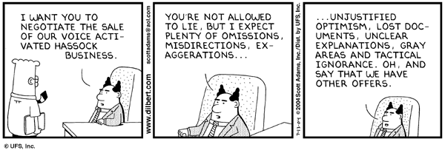
Figure 11.2 Dilbert’s ethical dilemma. (Dilbert © United Feature Syndicate. Reprinted by permission.)
A framework for considering decisions is shown in the 2x2 matrix shown in Figure 11.3 [Die00]. The idea is that decisions have both ethical and legal dimensions to them. The legality may be in terms of internal company policies or local, state, and federal laws. Quadrant I decisions are clearly to be avoided as they are not legal or ethical. Quadrant II decisions present an interesting dilemma since they are legal, but yet are not ethical. Making such a decision may not have punitive ramifications, but will have a negative impact on your professional reputation. Quadrant III decisions certainly feel right and are tempting, since they are moral but not legal. It is in Quadrants II and III where most moral dilemmas take place. Taken together, II and III represent opportunities for reform, to change the system positively so that ethical choices are legal and unethical choices are illegal. Left uncorrected, both lead to cynicism with the system, whether it is company policy or the legal system. Correcting them may take longer to address than the immediate dilemma, but have the potential for high payoff. Clearly, quadrant IV decisions are best and the goal in the decision process.

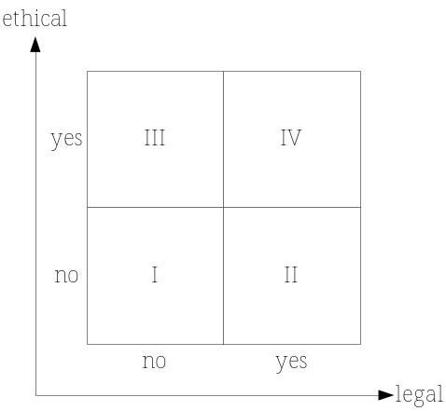
Figure 11.3 A 2x2 matrix for ethical decision making [Die00].
One way to evaluate a decision is through what is known as the newspaper test. The idea is to ask whether you would be comfortable if the decision were published in a newspaper for all to see. Advice from trusted friends or colleagues can be valuable, but if they are impacted by the decision, they may not be a good source. Many companies have an ethics office that provides guidance to which employees can turn. The IEEE and Online Ethics Center for Engineering and Science co-sponsor an ethics help-line at www.OnlineEthics.org, where ethical questions can be submitted.
There may be situations in which you are put in an ethical dilemma by your employer that cannot be resolved internally. As a last resort, you may go outside of the company to the press or a government agency to report the problem. This is known as being a whistleblower. An example of this is the space shuttle Challenger accident, in which the explosion was caused by O-ring failures in the booster rockets made by Morton-Thiokol. The engineers and scientists recommended against the launch, but their superiors at NASA and Morton-Thiokol went ahead over their objections. The engineers later “blew the whistle” by going public with this information. Although it was too late to avert the disaster, it was valuable in revealing what had happened and preventing future mishaps. The following criteria should be satisfied when considering becoming a whistleblower [Deg81]:
- The harm to the public must be considerable or serious.
- Concerns must have been made to your superiors (up to the CEO) without satisfactory resolution.
- You have documented evidence that would convince an impartial observer that your company is wrong. You should have clear technical information to support your claims.
- Release of the information outside of the company will prevent the harm.
Whistleblowing does have risks, particularly loss of job, but the risks may be well worth it. The Sarbanes-Oxley Act of 2002 improved federal protection of whistleblowers in the wake of corporate scandals in the 1990s.
  - Case Study Analysis
A good way to develop decision-making skills is by examining case studies. We now go through the steps of analyzing a case study, employing the IEEE Code of Ethics as a guide. In order to do so, we apply a paradigm that is a modification of the one used by Lockheed Martin Corporation in their employee ethics training programs [Loc97]. The modified paradigm is as follows:
- Gather information. What things are known about the situation, but also very importantly, what isn’t known, and what assumptions are being made?
- Identify the stakeholders. Who will be affected by the decision? They may include you, your company, your supervisors, your professional colleagues, your profession, the public, and users of your products.
- Consider what ethical values are relevant to this situation. Identify the elements of the IEEE Code of Ethics and legal issues that apply to the situation.
- Determine a course of action. Identify different alternative decisions and actions. Select the one that you believe best meets the interests of the stakeholders and the ethical values.
Example 11.1 demonstrates the application of this paradigm to a case study for a flawed chip design. More case studies are provided in the end of chapter problems.

Example 11.1 Ethics case study for a flawed chip design. (Texas A&M Ethics Case studies, http://ethics.tamu.edu. Reprinted by permission.)
Your company has designed a chip for a new scientific calculator that features high-precision floating-point accuracy to 17 significant digits for all 250 mathematical functions provided. After one-and-a-half years in development, and after shipping over 500 beta units to key customers, the company discovers a problem with certain calculations. In addition, the company has manufactured 5000 more calculators with this chip that are ready to be shipped.
In order to expedite floating point operations (used in handling scientific notation in mathematical operations) in a computer or calculator, certain tables of values often are used to assist in the speed of execution. (For example, a calculator requiring as long as 3 minutes to perform a tangent calculation would have no market appeal.) These tables can contain up to 100 integer entries. During beta testing, you discover that several of these values were incorrectly entered before burning them into the firmware.
Further testing concludes that because of the location and use of these table errors, the only mathematical results affected will occur in the 13th to the 17th significant digits for the double precision floating point operations. Your management is applying subtle pressure to release the chips due to the time and money invested in the project so far. Identify a plan of action.
Discussion:
Step 1: Gather information
The information makes it clear that the calculator may fail if precision beyond the 13th digit is needed. What is not known is the standard precision of a calculator. An Internet search of calculator specifications was conducted, and it was found that most scientific calculators have a 10 or 12-digit display plus two digits for the power. Going to the 13th digit implies a higher than normal precision calculator. A calculator with 17 significant digits would likely be used by scientists and engineers for high precision calculations.
Step 2: Identify stakeholders
The following are possible stakeholders:
- Users of the calculator. In certain situations, the user can make an incorrect calculation.
- Public. The users of calculator may perform calculations that could impact safety of public. This could be a real possibility given the likely users.
- Company and employees. There are negative ramifications of releasing a faulty product. This could result in monetary harm to the employees of the company that you work for.
Step 3: Identify relevant ethical values
Values from the IEEE Code are identified with a discussion of why they apply:
1: Release of the faulty calculator has the potential to endanger the safety of the public.
3: Need to be honest in stating claims as to the precision of the calculator.
9: There is clear potential to injure the reputation of the company and its employees.
In terms of legal issues, the company would be opening itself to claims of negligence, particularly since the defect was identified prior to release of the product.
Step 4: Determine a course of action
Three possible courses of action are:
A: Release the product as is without notifying the customers. This is not a good choice due to the potential harm to the safety of the public. This would not pass the newspaper test. It also may be illegal if the calculator is advertised to work to 17 significant digits.
B: Use the chips in a different calculator that is only guaranteed to compute at a lower precision, if such an option exists. The company would have to be producing one, and the technology would have to be compatible.
C: Throw away the chips and take a loss on their production and correct the problem. Conduct testing again to verify that the corrected chips work properly.
Options B and C are both reasonable choices. Option B reduces economic losses, but acceptance testing should be conducted to make sure they operate properly at the lower precision. Option C is the safest solution. Option A might be seen as a viable choice, however, since it could be reasoned that handheld calculators are not often used for safety critical applications. That is a risky assumption and the potential negative effects are great. Also note that the ideal situation would have been to develop a test plan (Chapter 7) that would have caught this error before release.
  - Project Application: Incorporating Ethics in the Design Process
There are good design practices that can be followed to minimize the chances that a product will be unsafe. The first and most important issue is to identify safety and health factors that impact the system and address them in the design. Its importance is reflected clearly as the first item in the IEEE Code of Ethics. It is a fundamental canon in virtually all professional engineering ethical codes. Be aware that there are often tradeoffs between economic and safety constraints and one may be satisfied at the expense of the other. It is also important to follow good practices throughout the design process. Ways that ethical considerations are included throughout the design process are:
- Conduct research so that prior art is understood. This will minimize conflicts over intellectual property ownership.
- Make sure that the requirements meet the needs of the stakeholders. If they do not, the wrong system will be designed. This is the concept of validation that was addressed in Chapter 3. Be honest and realistic in making claims about what the system can do and realize that all have limitations. There is often tension between engineering and marketing functions of an organization, with engineers often believing that marketing is overstating the capabilities of the product. A properly developed Requirements Specification is an effective tool for communicating the proposed system functionality to all parties.
- Identify and apply safety standards. There are many codes and guidelines that address safety in design for particular technologies. They should be identified and applied as necessary. For example, it may be wise to design a consumer product to meet UL (Underwriter’s Laboratory) guidelines. It may difficult to fully incorporate guidelines in a capstone design project, depending upon the complexity of the design and the standards. However, consideration should be given to identifying those that apply.
- Keep the design space large and explore as many solutions as possible. The hallmark of design is that there is typically no single solution to the problem, but many that may satisfice. Satisfice means that a solution may meet the design requirements, but may not be the optimal solution. It is important to fully understand the technical tradeoffs involved in a given design and their impact on health and safety.
- Consider all of the possible ways that a system can fail. This follows the IEEE Code of Ethics, which indicates that engineers should understand technology, its application, and potential consequences. This can be done formally through the use of techniques such as failure mode analysis and the examination of system reliability (Chapter 8). In safety critical systems, the use of redundant systems may be warranted to improve reliability. An excellent example of a technical design that incorporates redundancy in a safety critical application for a hot tub controller is found in the article Designing for Reliability, Maintainability, and Safety by George Novacek in Circuit Cellar magazine [Nov00, Nov01].
- Identify ways in which the system can fail by misuse or operator error. This requires thinking like a beginner who is completely unfamiliar with the technology. Provide manuals for operation and safety labels where appropriate.
- Make realistic cost and project schedule estimates. The IEEE Code of Ethics indicates that engineers should be honest and realistic in stating claims, and this applies to the project plan as well as the system cost.
- Conduct design reviews. The purpose of a design review is to have peers who are knowledgeable about the design and the technology conduct a review of the work you have done. This can be a humbling, but valuable, experience. It is also in keeping with the IEEE Code of Ethics, which indicates that engineers should seek, accept, and offer honest criticism of technical work and acknowledge and correct errors.
- Verify the engineering requirements during testing. We saw in Chapter 3 that verification is the process of showing that the system is built properly. Verification usually occurs at the end of a project at a time that there may be a great deal of pressure to complete the tests and finish the project.
  - Summary and Further Reading
This chapter provided a brief overview of ethics, morality, and different ethical decision making systems. The IEEE Code of Ethics was presented, which serves as a set of ethical values for the electrical and computer engineering profession and provides a basis for analyzing ethical dilemmas. Legal issues surrounding intellectual property and product liability were provided. Advice for incorporating safety and ethics in design projects was provided as well as a paradigm for analyzing case studies.
The background on ethical frameworks and its importance in engineering came from a number of articles. The article What has Ethics to do with me?: I am an Engineer [Gob99] provides background on rule-based ethics, universality, and transitivity. A Piercian Approach to Professional Ethics Instruction [Cha02b] addressed ethical decision-making frameworks. Ethical Considerations in the Engineering Design Process [Van01] emphasizes the need to keep the design space as large as possible. The article Integrating Ethics and Design [Mcl93] does a good job of describing three different levels of ethical decision making in technical, professional, and social contexts. The two engineering design textbooks by Dieter [Die00] and Hyman [Hym98] are good resources on legal and intellectual property issues. The United States Patent and Trademark Office has an excellent website (www.uspto.gov) with information on patents, applying for a patent, and a searchable patent database. The website www.HowStuffWorks.com is also a good source on ethical theory, patents, and legal issues surrounding product liability.
  - Problems
  - Describe the relationship between ethics and morals.
  - Describe the differences between morals and values.
  - Which patent is most relevant for engineering inventions, a design patent or utility patent? Why?
  - What are the criteria that are used in evaluating patents?
  - Explain the importance of claims in a patent application.
  - Discuss the tradeoffs involved between using patents and trade secrets to protect intellectual property.
  - When can reverse-engineering be used, and how can the information obtained from it be used?
  - What is the difference between negligence and strict liability in tort law?
  - For the case study presented below, apply the ethical decision making paradigm presented in Section 11.5 to analyze the situation. Present potential solutions to the scenario and provide a discussion of them.
Case Study: Disk Drive Diagnostics. (Copyright John Wallberg. Reprinted by permission.)
SCSI, an industry standard system for connecting devices (like disks) to computers, provides a vendor ID protocol by which the computer can identify the supplier (and model) of every attached disk.
Company C makes file servers consisting of a processor and disks. Disks sold by C identify C in their vendor ID. Disks from other manufacturers can be connected to C's file servers; however, the file server software performs certain maintenance functions, notably pre-failure warnings based on performance monitoring, only on C-supplied disks.
Company P decides to compete with C by supplying cheaper disks for C's file server. They quickly discover that while their disks work on C's file servers, their disks lack a pre-failure warning feature that C's disks have. Therefore, the CEO of P directs you, the engineer in charge of the disk product, to find a solution to the problem of no pre-failure warning for your disks. Using reverse engineering, you discover that by changing the vendor ID of P’s disks, the C file servers will treat P disks as C disks. Your management at company P instructs you to incorporate this change into your product so that you can advertise the disks as “100% C-compatible.” What would you do in this situation?
  - For the case study presented below, apply the ethical decision making paradigm presented in Section 11.5 to analyze the situation. Present potential courses of action and provide a discussion of them.
Case Study: Encryption Software (Texas A&M Ethics Case Studies, http://ethics.tamu.edu. Reprinted by permission.)
You are a recently hired engineer who has been recruited directly out of college. For your first assignment, your boss asked you to write a piece of software to provide security from "prying eyes" over emailed documents; these documents would be used internally by the company. This software will subsequently be distributed to different departments.
Upon completion of this software project, you saw a program on the local news about an individual in California who has made similar software available overseas. This individual is currently under prosecution in a federal court for the distribution of algorithms and information which (by law) must remain within the United States for purposes of national security.
It occurs to you that your company is a multinational corporation and that the software might have been distributed overseas. You then discover that the software has indeed been sent overseas to other offices within the corporation. You speak with your boss, informing him of the news program from the night before. He shrugs off this comment, stating that “The company is based in the United States and we are certainly no threat to national security in any way. Besides, there's no way anyone will find out about software we use internally.”
You agree with your boss, and let it go. Later on however, you receive a letter from a gentleman working as a contractor for his company overseas. Through some correspondence regarding the functionality of the software and technical matters, you learn that the Middle Eastern office had been supplying his software outside the company to contractors and clients so that they could exchange secure emailed documents. What would you do in this situation?
  - For the case study presented below, apply the ethical decision making paradigm presented in Section 11.5 to analyze the situation. Present potential courses of action and provide a discussion of them.
Case Study: A Failure. (Texas A&M Ethics Case Studies, http://ethics.tamu.edu. Reprinted by permission.)
You work for Velky Measurement which has for years provided DGC Corporation with sophisticated electronic equipment for patient health monitoring systems. Recently, DGC returned a failed piece of measurement equipment. A meeting was held with representatives of Velky and DGC to discuss the problem. This included you and your project manager who is intimately acquainted with the returned equipment. During the course of the meeting it becomes apparent to you that the problem has to be Velky's. You suspect that the equipment failed because of an internal design problem and that it was not properly tested. However, at the conclusion of the meeting your project manager represents Velky’s official position—the test equipment is functioning properly.
You keep silent during the meeting, but afterwards talk to your project manager about his diagnosis. You suggest that Velky tell DGC that the problem is due to a design fault and that Velky will replace the defective equipment. You manager replies, “I don't think it's wise to acknowledge that it's our fault. There's no need to hang out our wash and lessen DGC's confidence in the quality of our work. A good will gesture to replace the equipment should suffice.”
Utlimately, Velky’s management replaces the equipment because DGC has been such a good customer. Although Velky replaces the equipment at its own expense, it does not disclose the real nature of the problem. What would you do in this situation?

  - For the case study presented below, apply the ethical decision making paradigm presented in Section 11.5 to analyze the situation. Present potential courses of action and provide a discussion of them.
Case Study: A Vacation (Texas A&M Ethics Case Studies, http://ethics.tamu.edu. Reprinted by permission.)
You work for Rancott and were looking forward to an upcoming trip for weeks. Once you were assigned to help install Rancott’s equipment for Boulding Corporation, you arranged a vacation at a nearby ski resort. The installation was scheduled to be completed on the 12th and your vacation would begin on the 13th. That meant a full week of skiing with three of your old college buddies.
Unfortunately, not all of the equipment arrived on time. Eight of the ten identical units were installed by mid-morning on the 12th. Even if the remaining two units had arrived that morning, it would take another full day to install them. However, you were informed that it might take as long as two more days for the units to arrive.
“Terrific,” you sighed, “there goes my vacation—and all the money I put down for the condo.” “No problem,” replied Jerry, the Boulding engineer who had worked side-by-side with you as each of the first eight units was installed. He said “I can handle this for you. We did the first eight together. It's silly for you to have to hang around and blow your vacation.” Jerry knew why you were sent to supervise the installation of the new equipment. It had to be properly installed in order to avoid risking injuries to those who use it. Although you are aware of this, you are confident that Jerry is fully capable to supervise the installation of the remaining two units. What would you do?

